Arica Conrad

BIT 465 – REST API Development

March 6, 2022

Assignment 5 - Complete Django REST API with GitHub Documentations

Instructions

This assignment is to help you build upon the skills you have acquired from assignment 4 and the first 4 chapters of Building RESTful Python Web Services. See the submission section for more information about what you should submit for this assignment.

You should build a new API endpoint that allows an end user to create a new *Dog* model by making a *POST* to */api/dogs*, view current dogs that have been saved to the server before by making a *GET* to */api/dogs*, and get, modify, or delete an existing *Dog* record by making a *GET*, *PUT*, or *DELETE* request (respectively) to */api/dogs/<id>* where *<id>* is the id of the Dog record to be retrieved, modified, or deleted. Since a Dog includes a foreign key to the breed, you also need to make the same type of endpoints for dog breed at */api/breeds/* and */api/breeds/<id>*.

Submission

Submit a Word document containing a link to your GitHub repository for this assignment along with the requirements in the grading rubric.

Link to GitHub Repository

Here is the link to my GitHub repository: [AricaLConrad/Assignment-5-Complete-Django-REST-API-with-GitHub-Documentations: Assignment 5](https://github.com/AricaLConrad/Assignment-5-Complete-Django-REST-API-with-GitHub-Documentations).

Part 1: Database

The SQLite database:

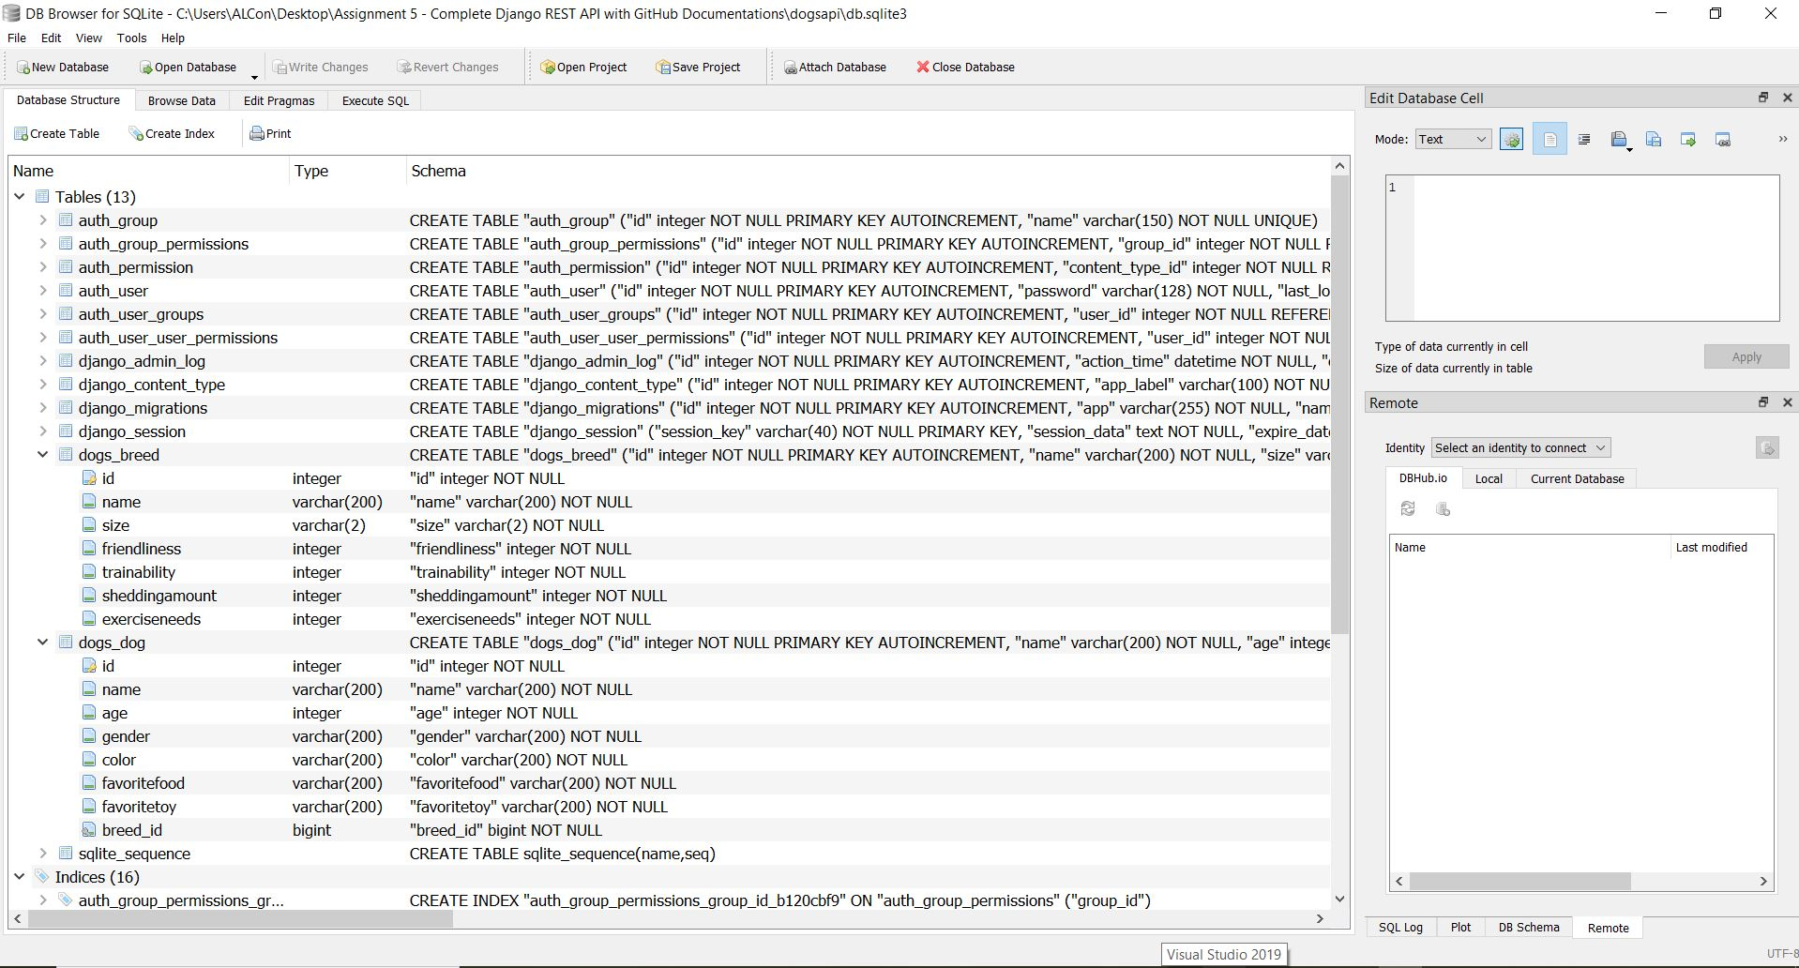

Part 2: Browsable API – List View

Api-root page:

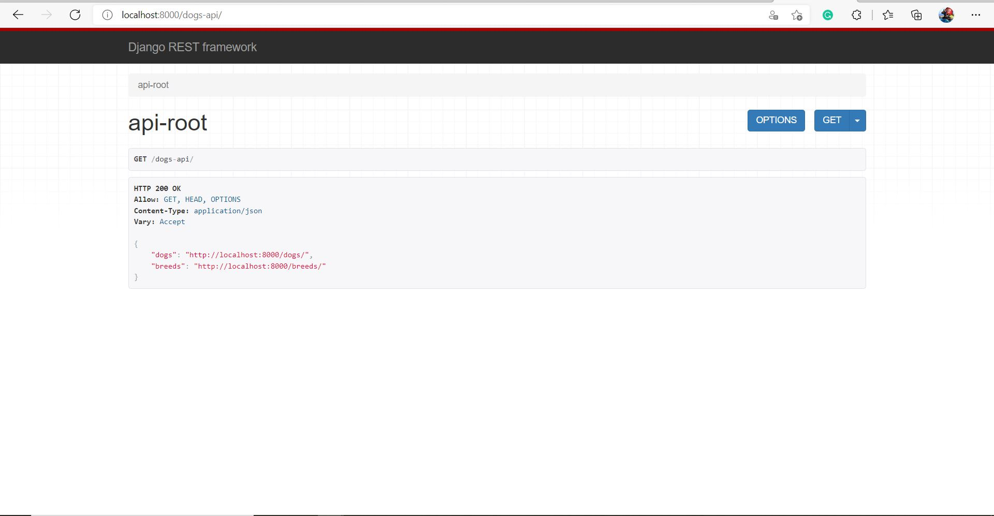

The Dog-List page:

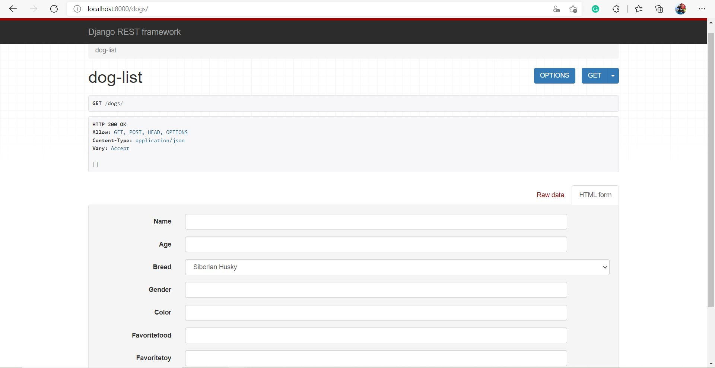

The Breed-List page:

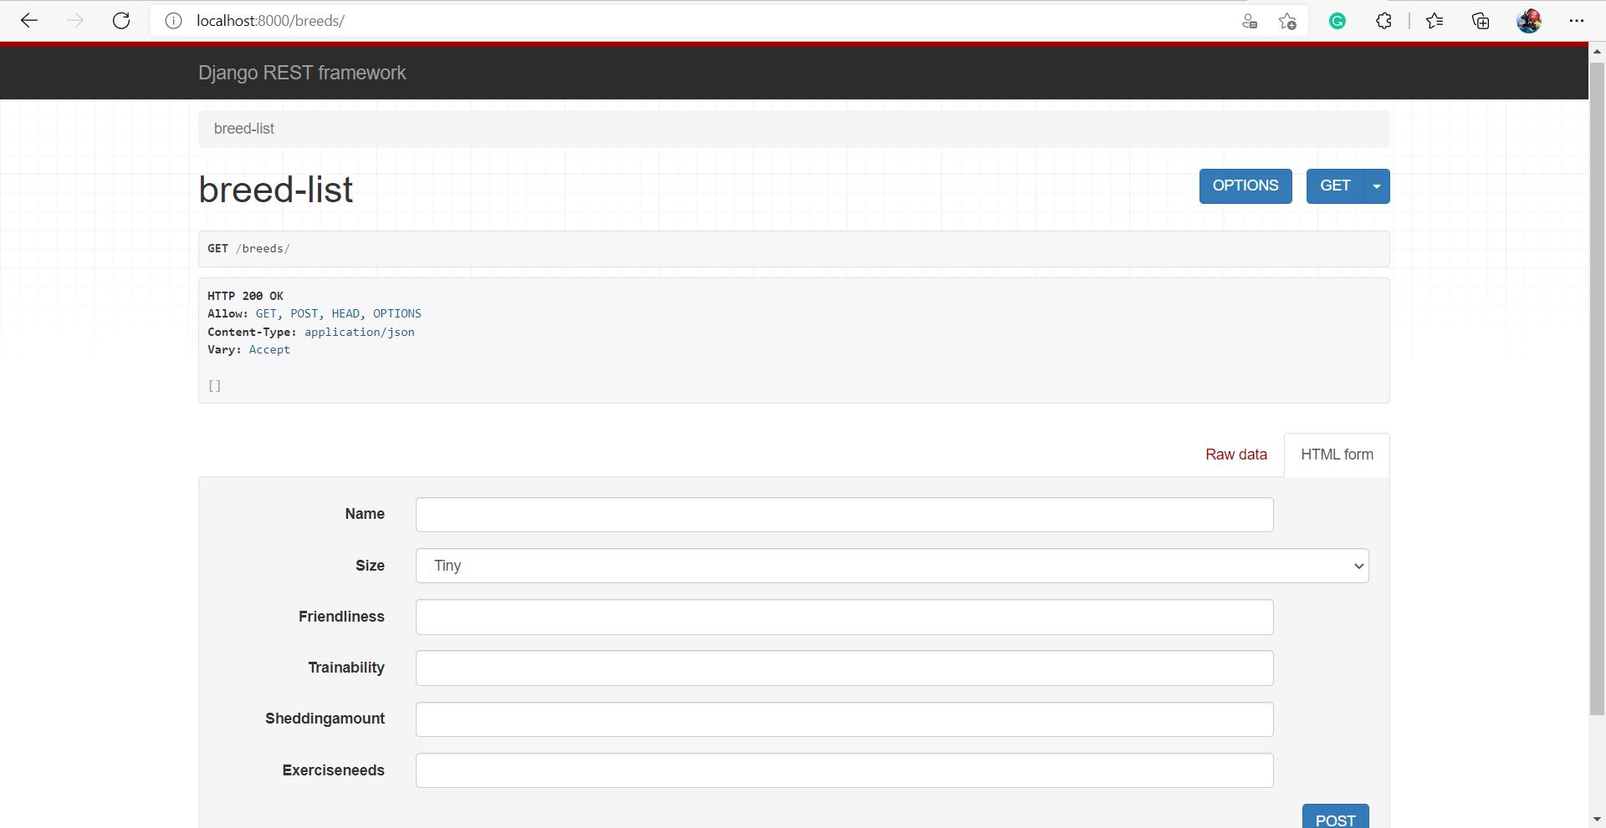

Part 3: Browsable API – Detail View

A Dog-Detail page:

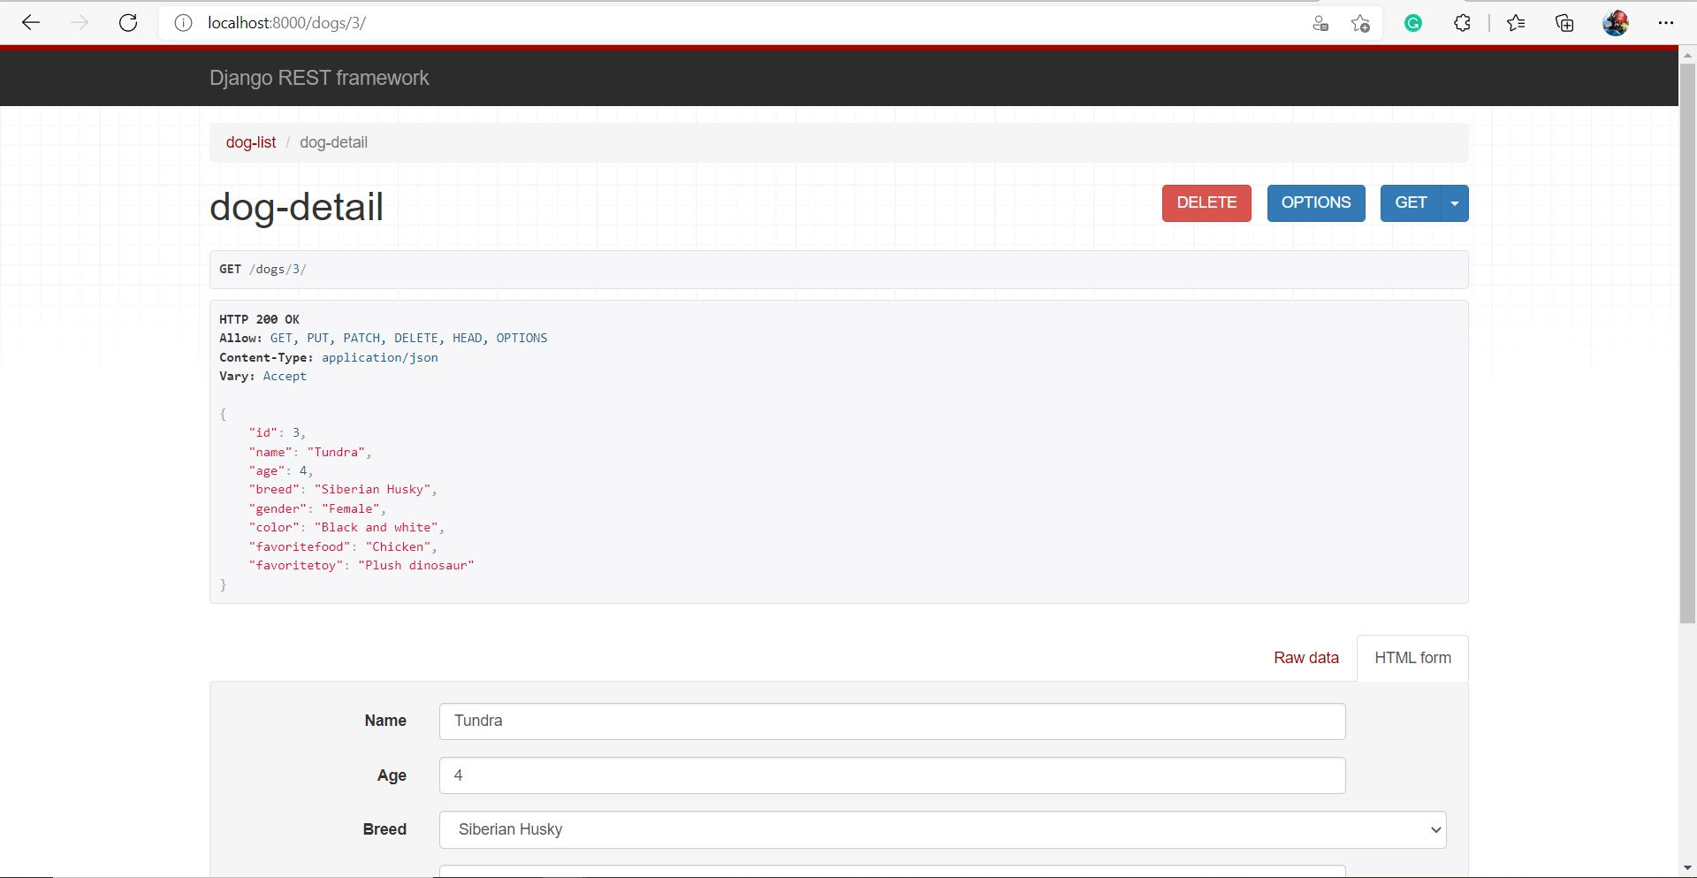

A Breed-Detail page:

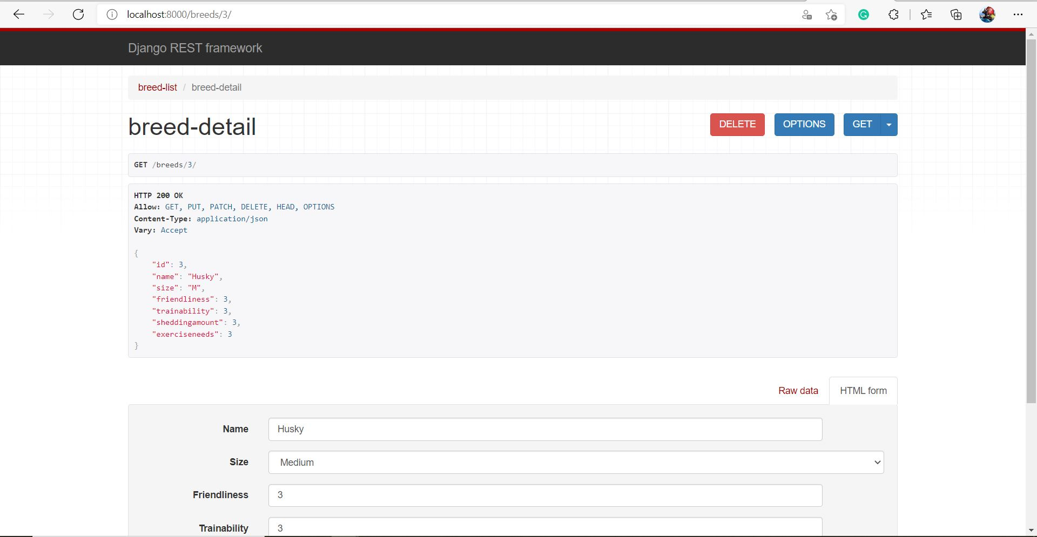

Part 4: Endpoints Testing

Breed-List GET all request:



Breed-List POST request:

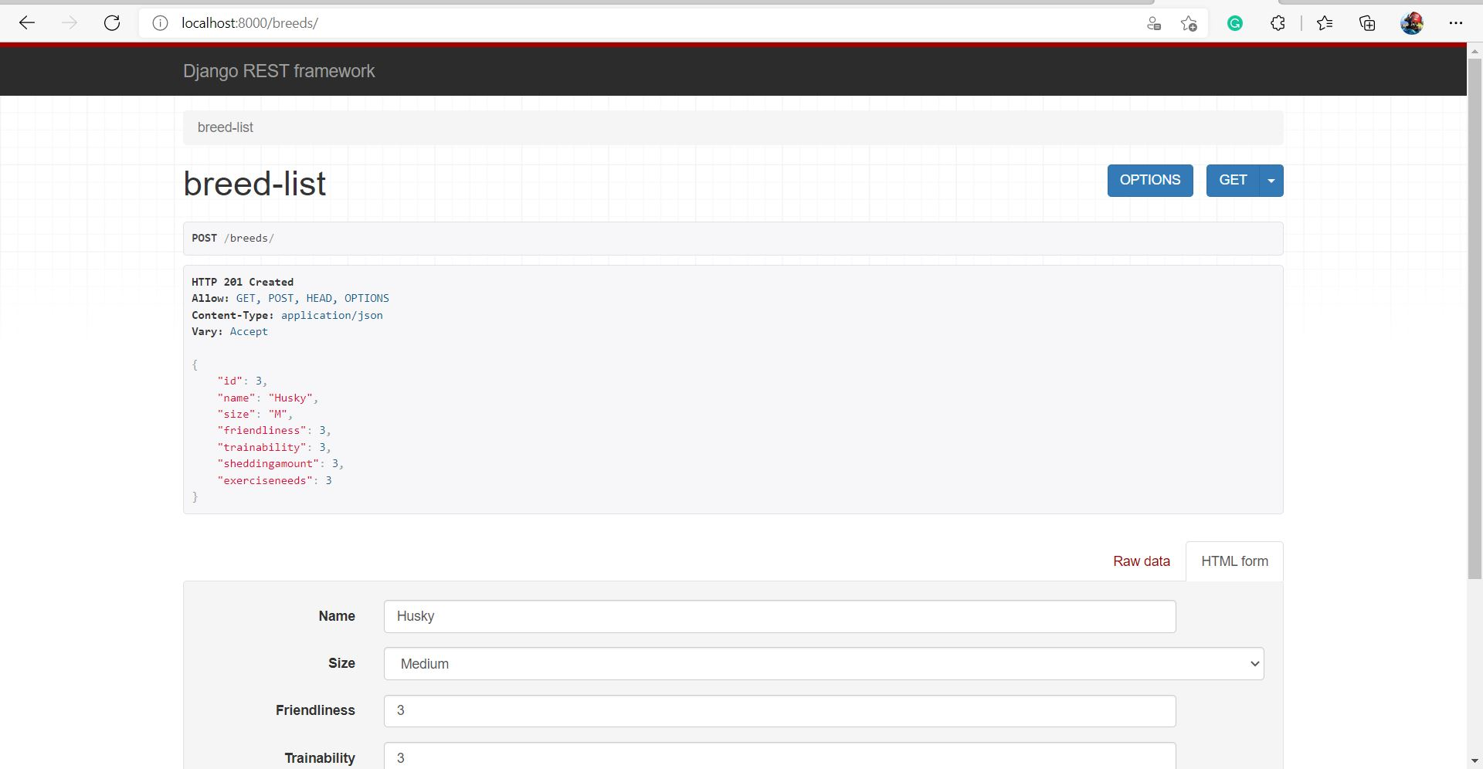

Breed-Detail GET one request:



Breed-Detail PUT request:

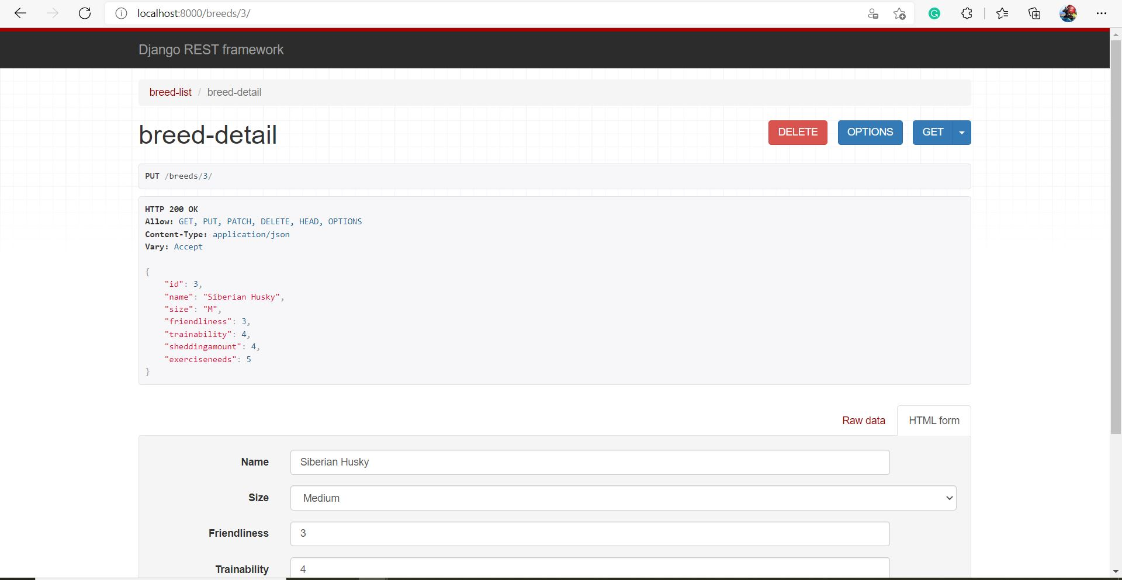

Breed-Detail DELETE request:

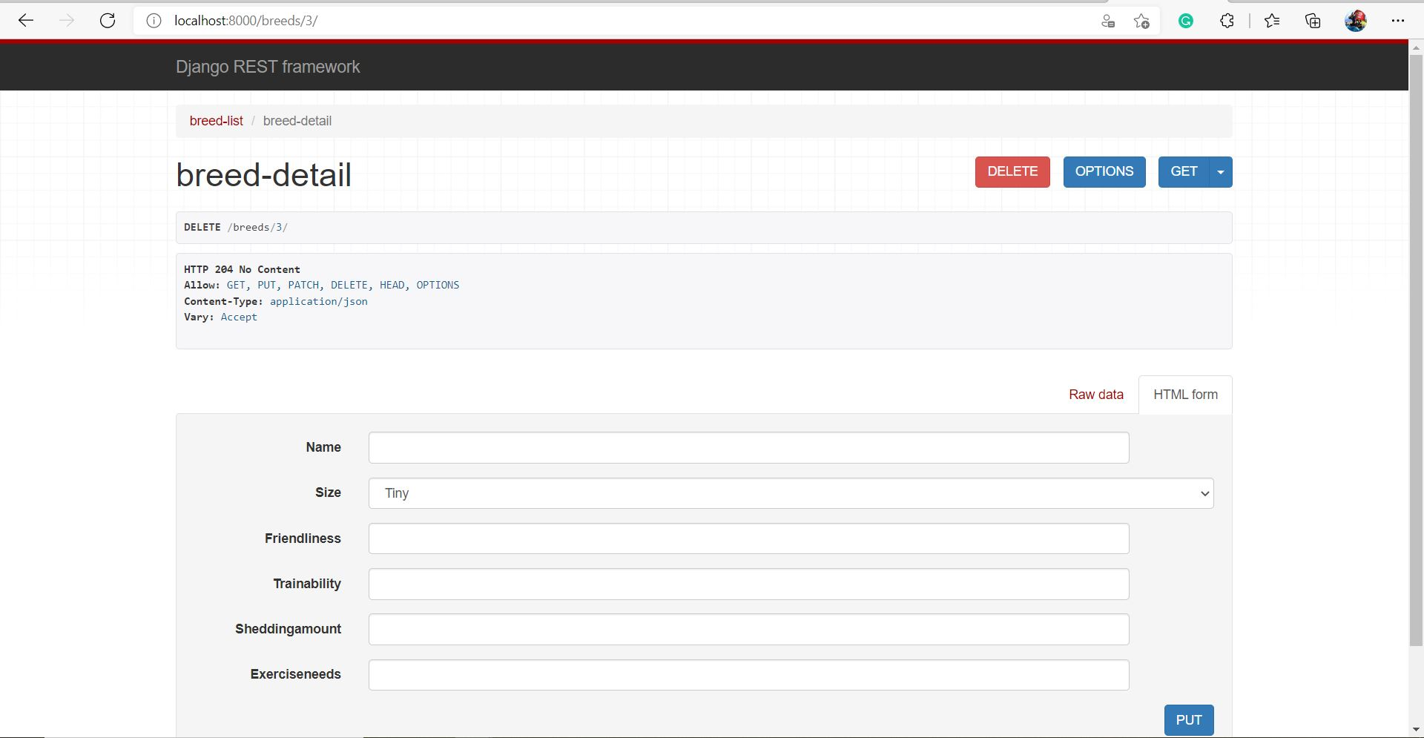

Dog-List GET all request:



Dog-List POST request:

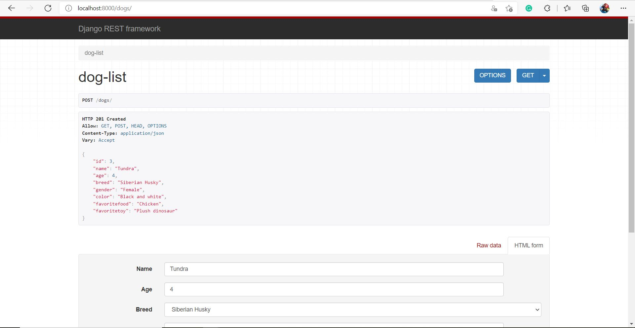

Dog-Detail GET one request:



Dog-Detail PUT request:

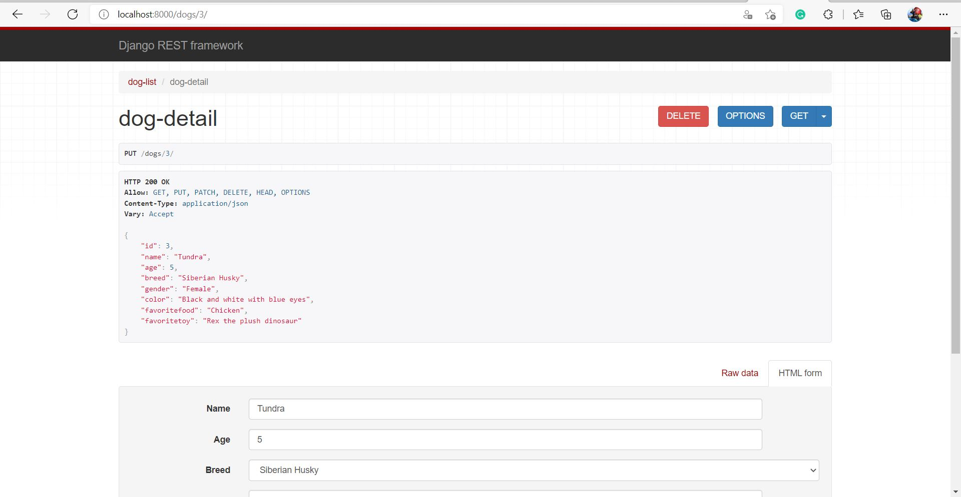

Dog-Detail DELETE request:

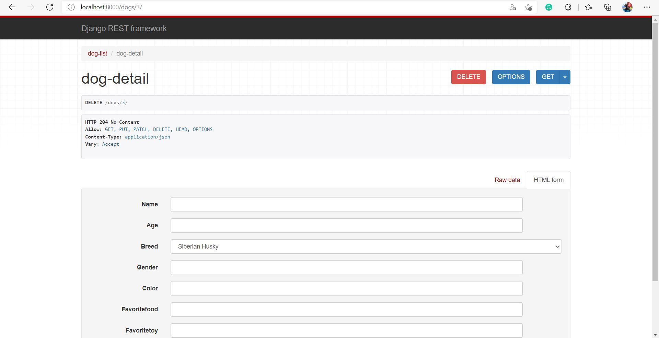

Some of the server responses:

